**Project 45:  
Remote Control Camera**

**Cal Poly CPE 329-01**

**Spring 2017**



Brendan Baronia

Melinda Ong

Professor Gerfen, Jeffrey B.

**June 14, 2017**

Introduction

The objective of this system is to integrate two MSP432 boards with an infrared diode LED IR Emission and Receiver, gamepad, camera module, and an Arduino Uno in order to capture photos using a remote control.

One MSP432 board will interface the gamepad to the IR transmitter. This system will be enclosed and will operate off battery power, using 2 AAs to power the MSP432 and an additional 2 AAs to boost power to the IR emitter.

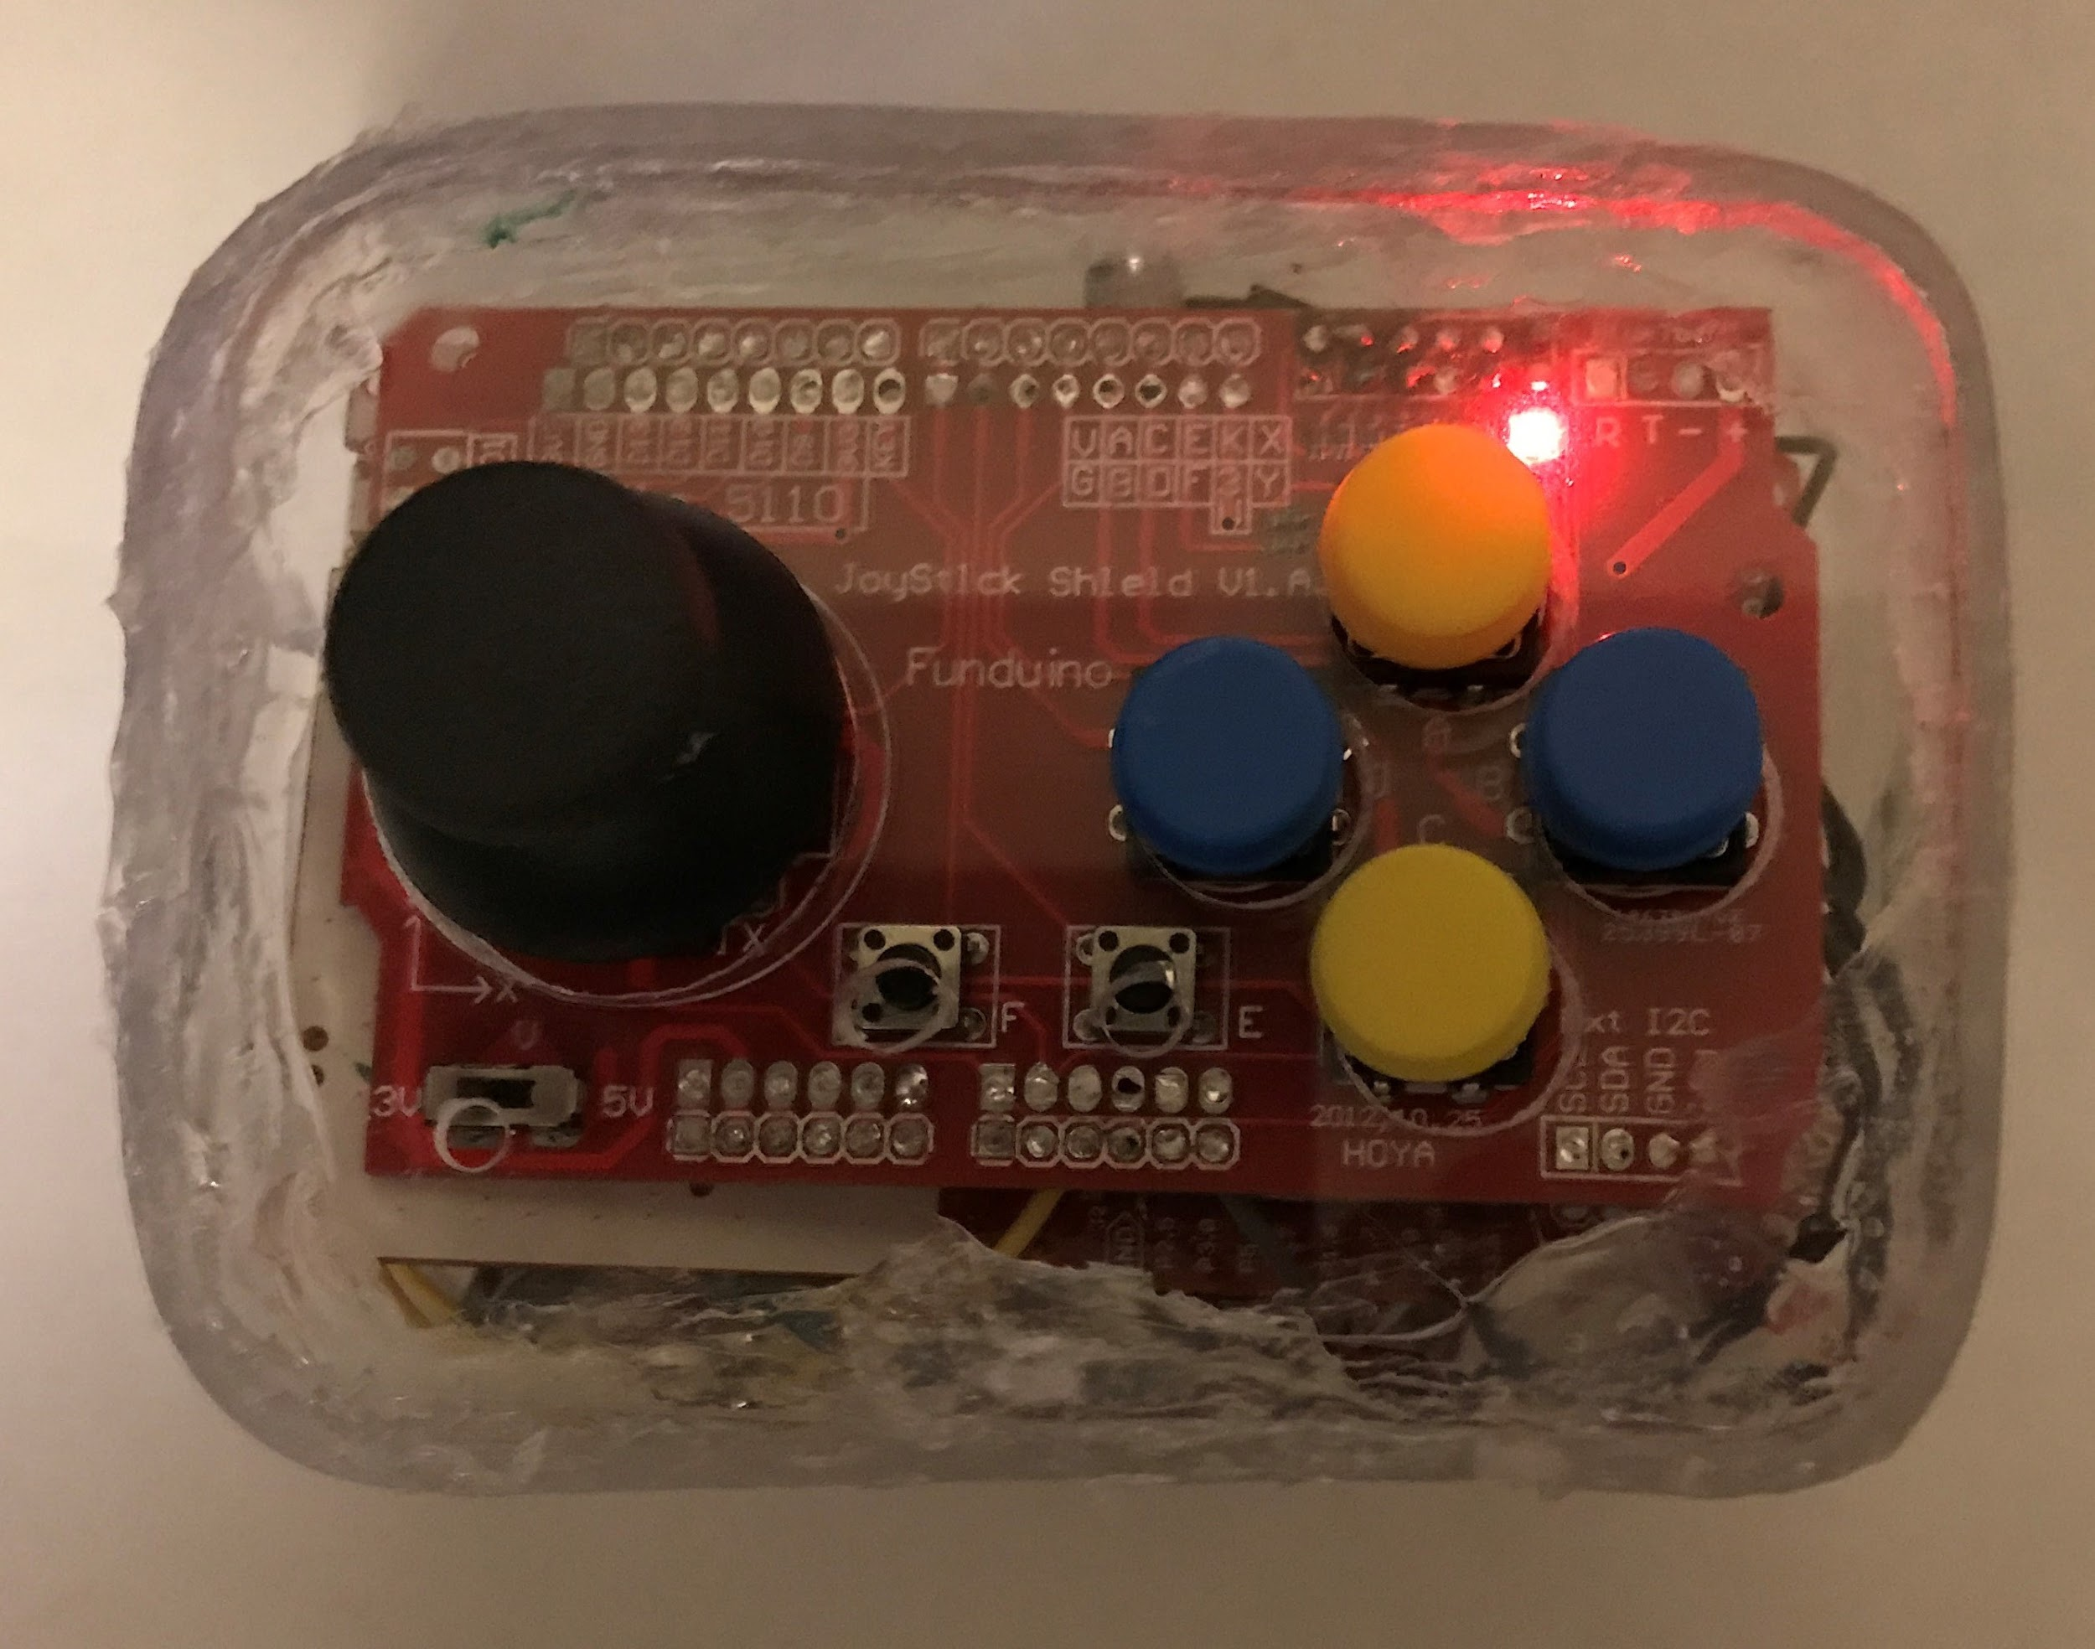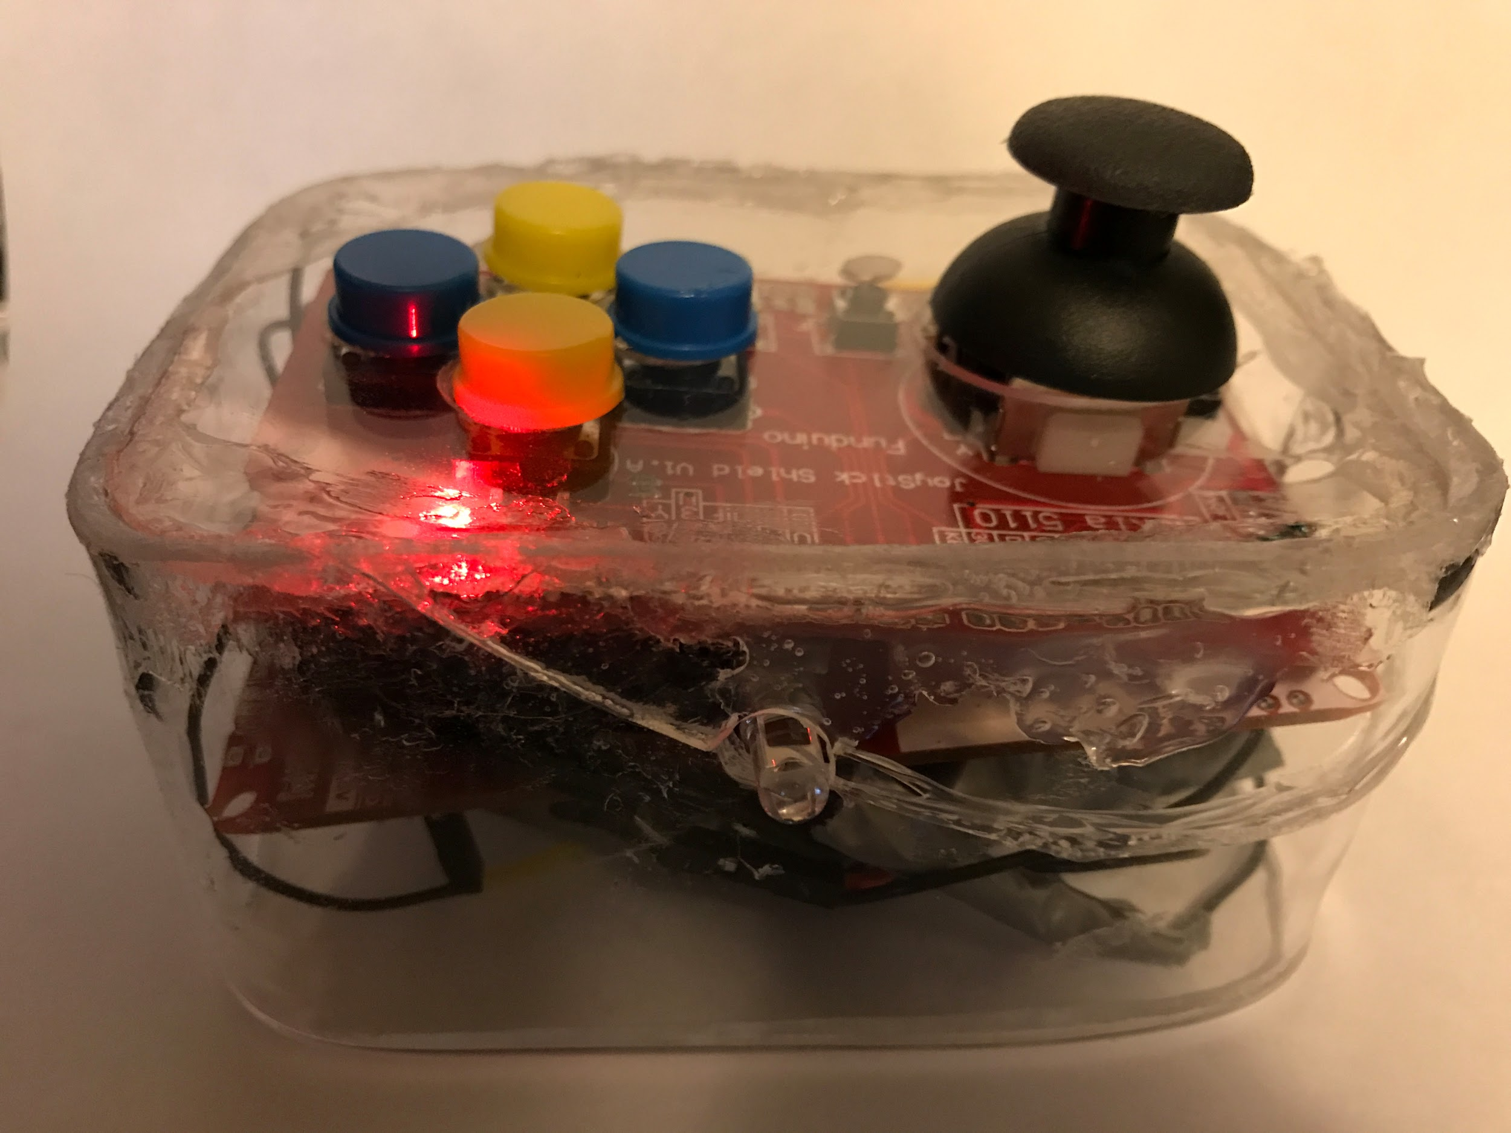

**Images 1-2: Final and Functional Remote Enclosure**

A second MSP432 will interface the IR receiver with the Arduino, which will control picture transmission. The second MSP432 will be powered off of a Micro-USB cable and the Arduino will also utilize an A/B Printer to USB cable and a serial port to transmit pictures to a connected PC.

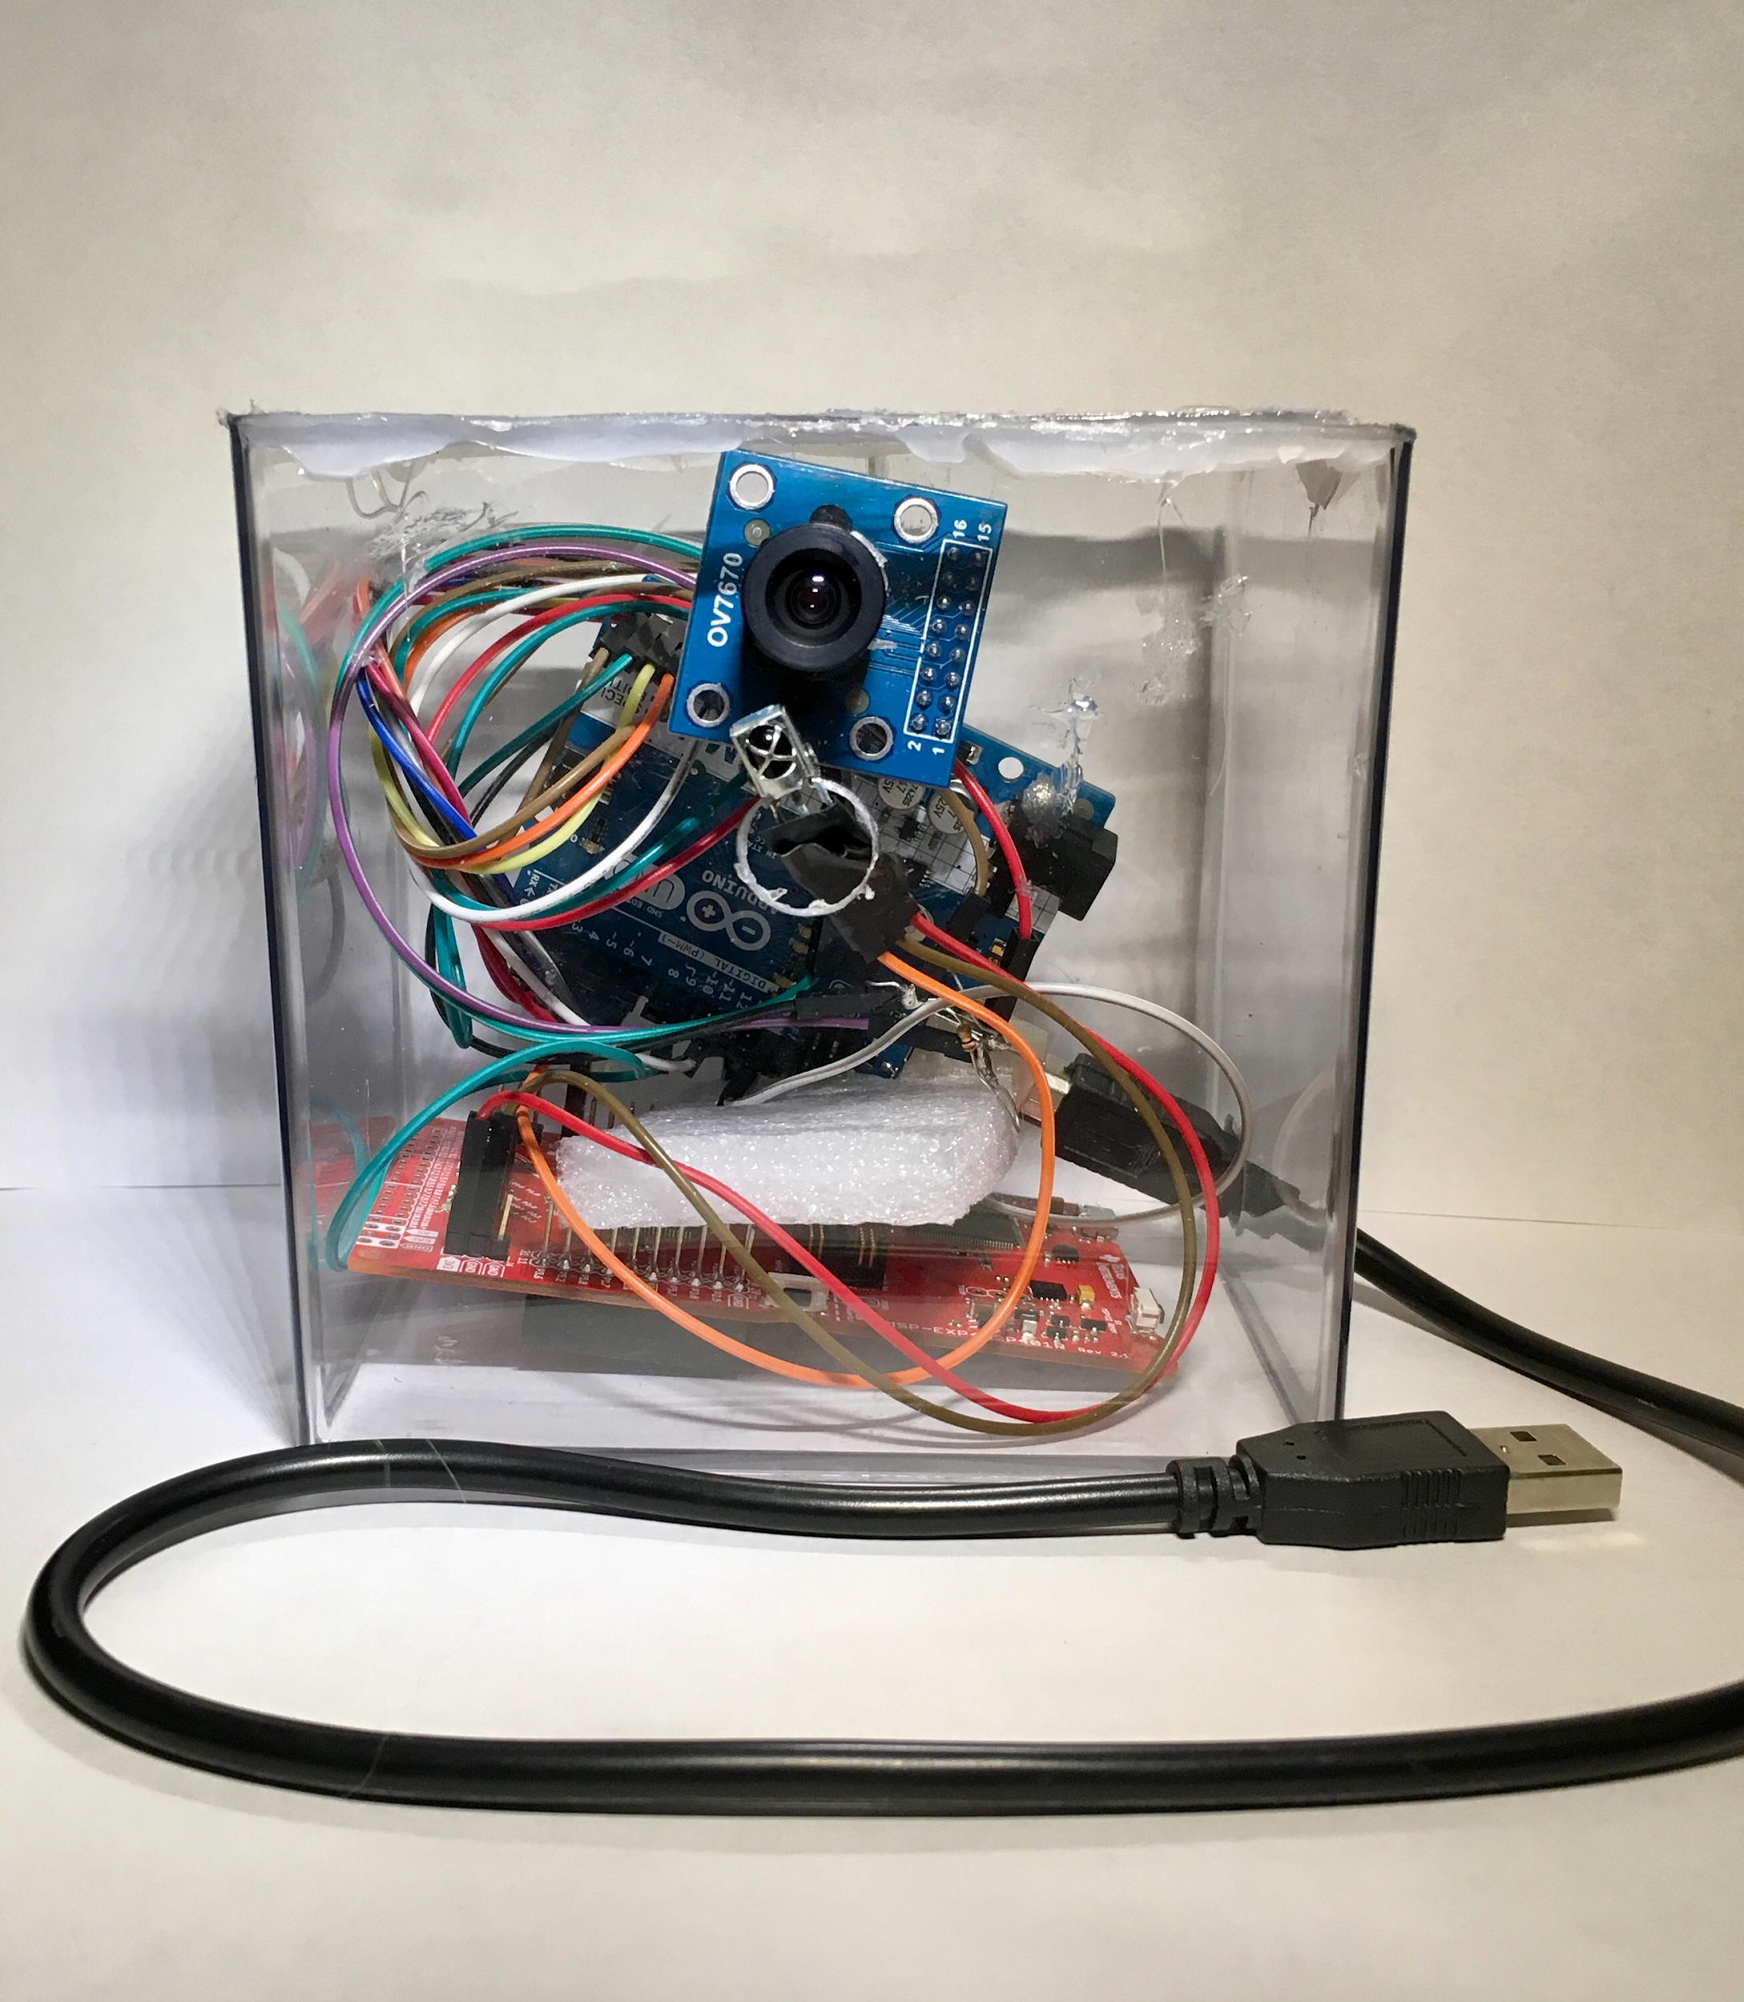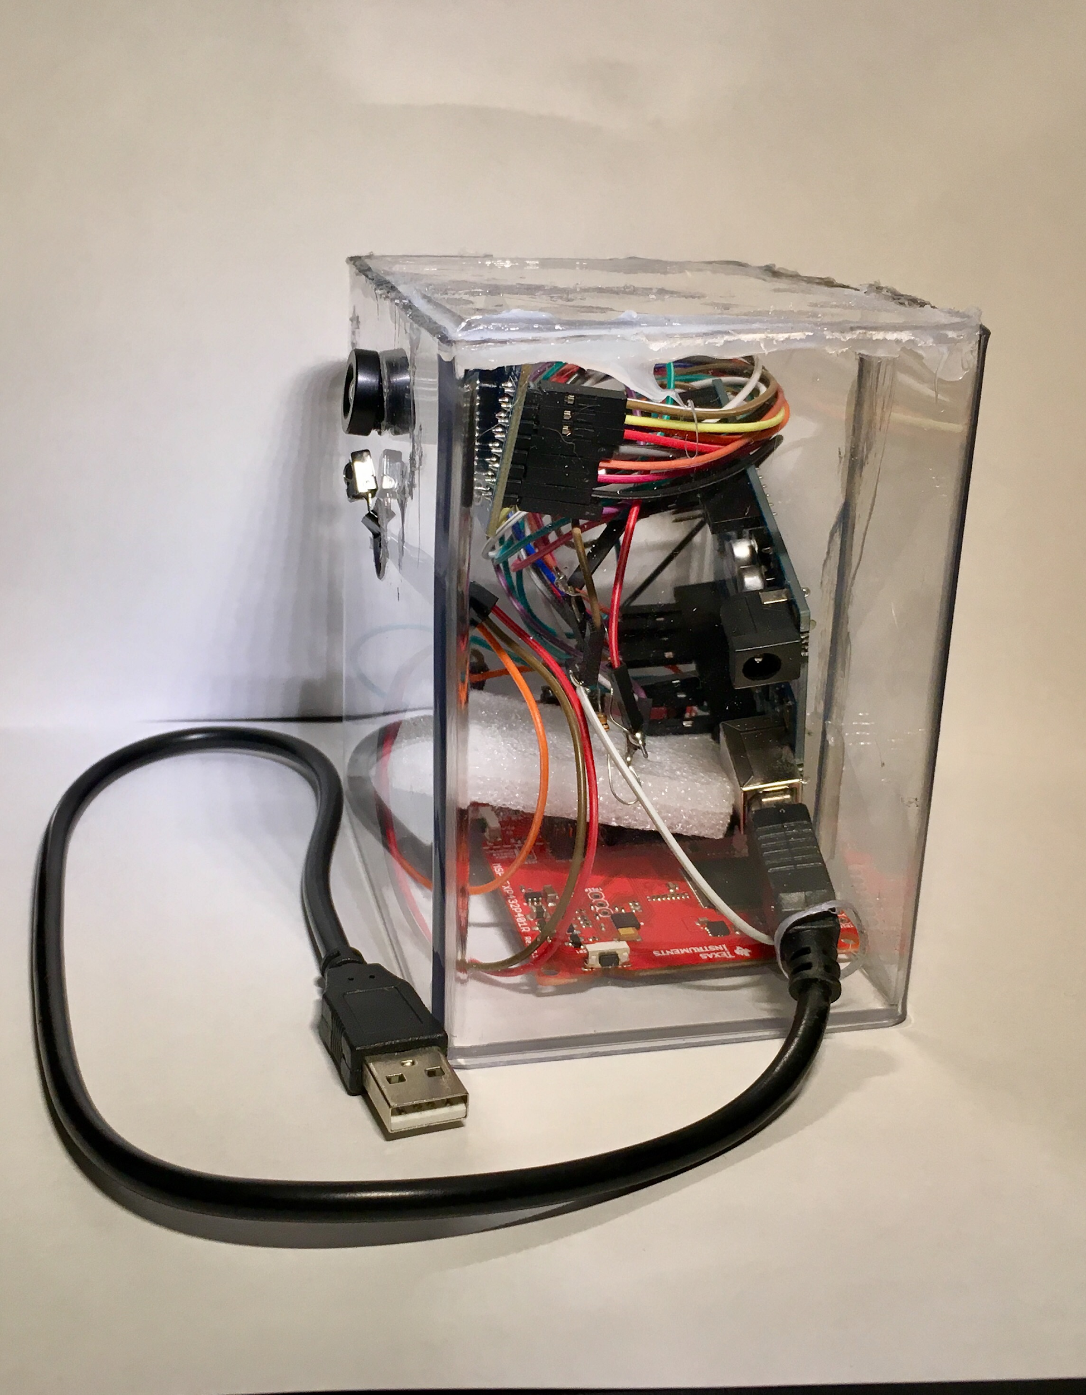

**Images 3-4: Final and Functional Camera Enclosure**

The camera sensor can be calibrated by adjusting the outside lens of the camera. Below are the resulting images taken by the system:

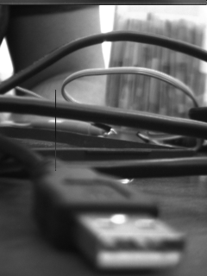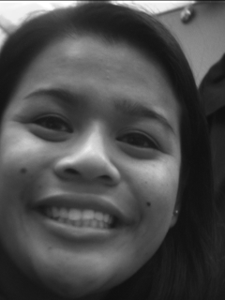

**Images 5-7: Example Images Taken from Remote-Controlled Camera**

Requirements

1. Shall utilize an infrared diode LED Emission/Receiver sensor as a central theme to the system
   1. Sensor must be interfaced and calibrated as an intermediate deliverable
2. Shall operate as a stand-alone system that provides utility and performs a useful job for the user
3. Shall utilize a serial console capable of monitoring the system parameters in real time and allow system configuration without recompilation in the development environment
4. Shall operate with battery power
   1. The design and operation of the battery power system, including calculations and measurements to predict system autonomy (battery life) shall be documented in the report
5. Shall be housed in a self-contained enclosure

System Specification

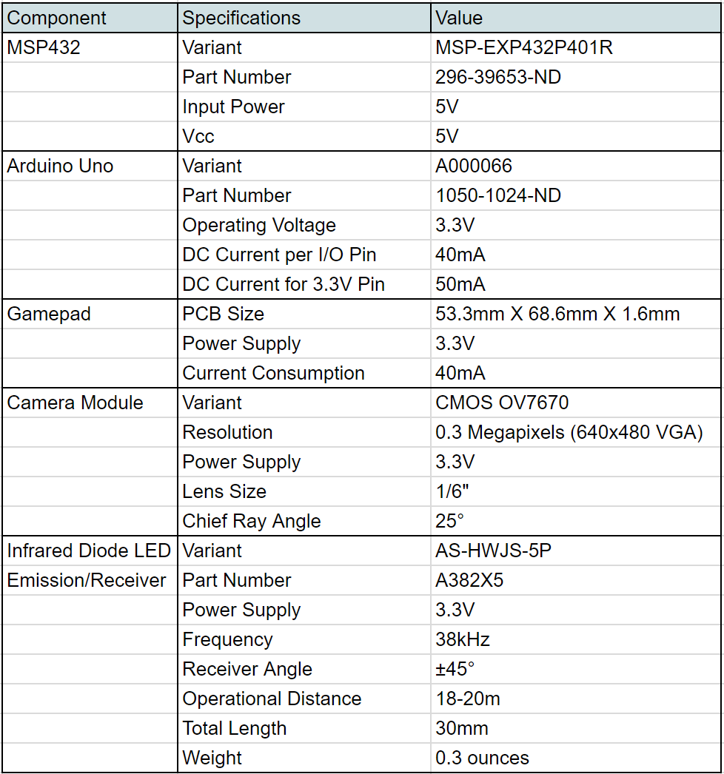

**Table 1: System Specifications**

System Architecture and Design

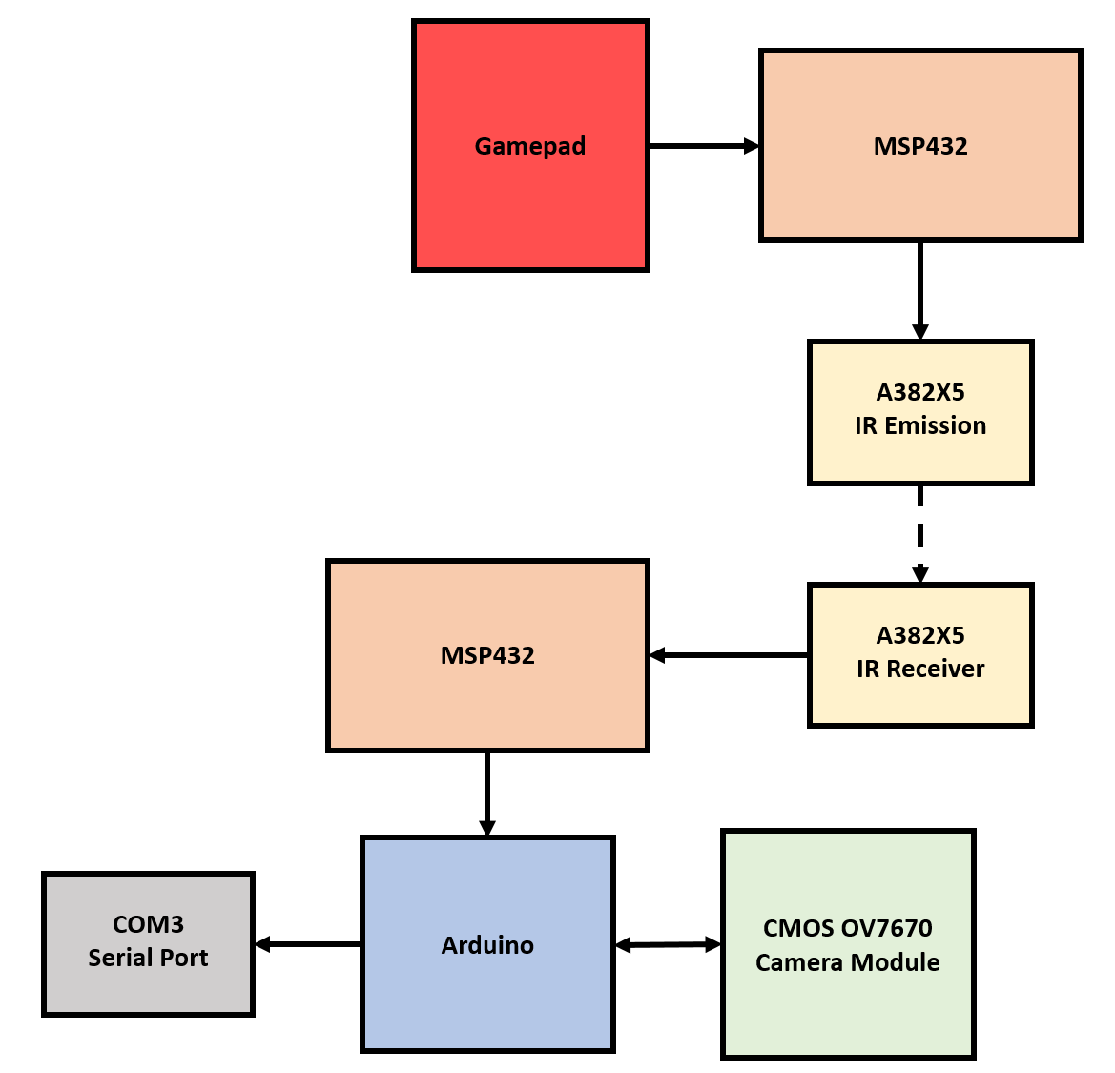

**Figure 1: Overall system block diagram**

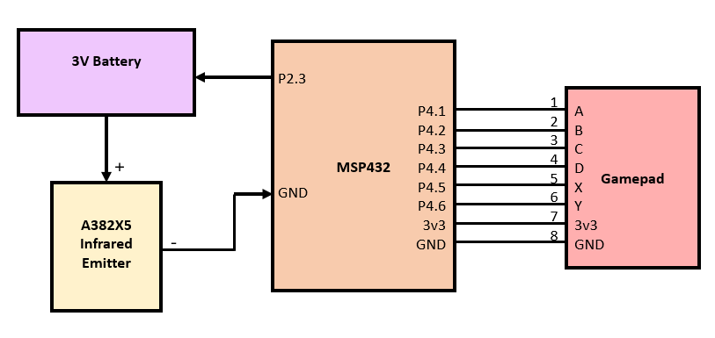

**Figure 2: Remote Schematic**

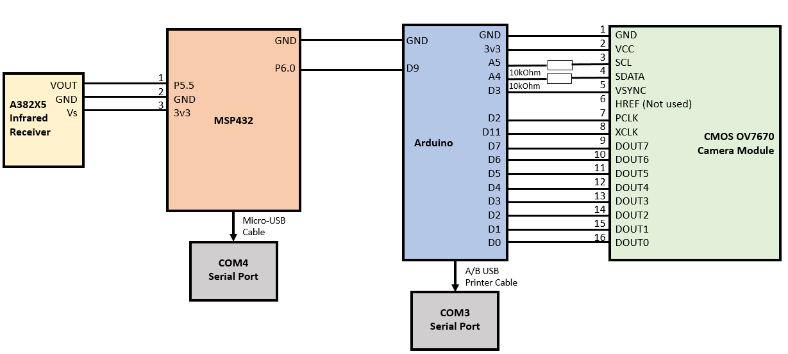

**Figure 3: Camera Schematic**

*Technical Description of the System*

This system utilizes two MSP432s to create a completely controlled IR system. The first MSP432, attached to the gamepad and IR emitter, is tasked with reading input signals from the gamepad, encoding them over IR, and transmitting them using the emitter. The second MSP432, attached to the Arduino and the IR receiver, is tasked with decoding all IR transmissions and properly signalling the Arduino to take a picture. The Arduino is tasked with processing the MSP432 signal, signalling the OV7670 to take a picture, reading all camera data, and transmitting that data over a serial port to an attached computer.

On a hardware level, the first MSP432 must provide six input pins and one output pin. The Funduino gamepad has active low button inputs for four buttons, as well as two signals for X and Y positions. The IR emitter, to achieve the necessary brightness, utilizes a 10 ohm current limiting resistor, a high drive output from the MSP432, and a secondary 3V power source in series to create a 38 kHz IR signal. The current software loaded onto the MSP432 transmits a basic signal over IR when the A button is pressed, signaling the receiver to take a picture. However, the software can read from all four buttons and the joystick for further system expansions.

On a hardware level, the second MSP432 must provide one input pin and one output pin. The input pin is attached to the IR receiver, which is active low. The IR receiver includes a chip to demodulate 38 kHz IR signals, creating a constant output. The MSP432 processes signals from the system and provides an active high output signal to the Arduino. Currently, this MSP432 listens for all IR signals to take a picture, but like the first MSP432, is designed for further expansion.

The OV7670 Camera Module provides the full functionality of a single-chip VGA camera and processor. In the system, it captures full-frame images controlled through the Serial Camera Control Bus (SCCB) interface. The module utilizes sensor technology in order to improve image quality by reducing fixed pattern noise (FPN) to produce a fully stable image. The camera module is powered from a single 3.3V power supply on the Arduino Uno. An external oscillator provides the clock source on the XCLK pin. With proper configuration to the camera’s internal registers via the I2C bus, the camera supply pixel clock (PCLK) and camera data (Data[7:0]) synchronize the signal VSYNC. With this hardware and software configuration between the Arduino Uno and OV7670 Camera Module, the system is capable of capturing an image based on the user’s remote control input, as well as, saving the image to a folder in the user’s C:/ drive.

*Battery Powered Operation*

Since the system is implemented as a remote control camera system, the first MSP432 was designed to be battery powered. This allowed the remote system to be fully portable and self powered.

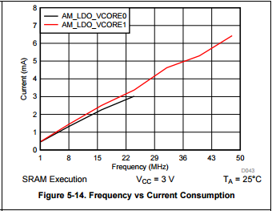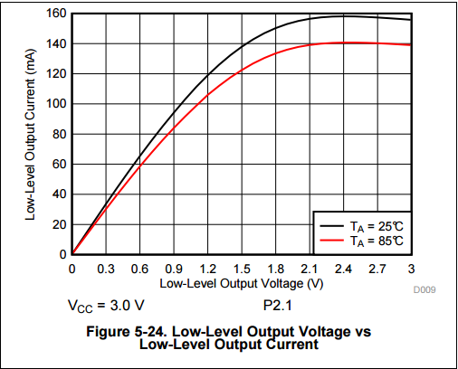

Using the supplied 40 mA specification for the gamepad and a theoretical maximum current draw of 160 mA from the high drive pin on the MSP432, as well as the MSP432’s estimated 1.5 mA of current consumption based on a While(1) program, this system’s theoretical current draw with a button pressed is 201.5 mA. Without a button pressed, the current consumption from the high drive pin will decrease to 0, so the system’s theoretical current draw will be 41.5 mA.

As most remotes are used, very little time is spent with a button pressed. Since the Arduino must reset after each picture taken, which takes multiple seconds, the theoretical maximum rate of pressing the button to take a picture is approximately 13%. With the button press and signal taking approximately half a second, three and a half seconds are provided for the Arduino system to take the picture and reset.

Using a 13% duty cycle with 201.5 mA current consumption during high load and 41.5 mA current consumption during low load, the following calculation provides an estimated total current draw.

$201.5mA(0.13) + 41.5mA(0.87) = 62.3mA$

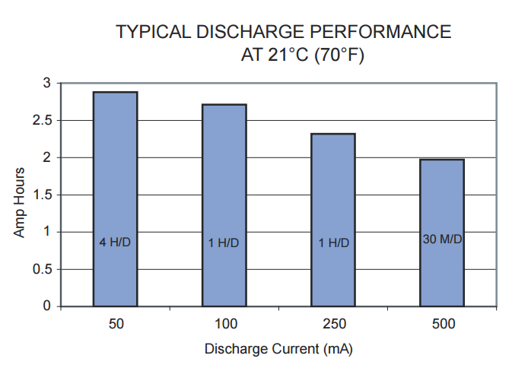

Using the Duracell datasheet for AA batteries, the two AA batteries in series should provide approximately 2.75 Ah of service given a 62.3 mA average load. The autonomy can then be calculated.

$\frac{2.75Ah}{62.3 mA}=44h$

Therefore, the theoretical autonomy time of the system is 44 hours.

However, by using a multimeter in series with the system, actual current draw was measured to be 2.71 mA with no button pressed, and 13.9 mA with a button pressed. Using these figures, with the same 13% duty cycle, autonomy can be recalculated.

$2.71mA(0.87) + 13.9mA(0.13) = 4.16mA$

This load is far less than the datasheet provides estimates for, so the maximum provided value of 2.9 Ah is assumed.

$\frac{2.9Ah}{4.16mA}=697h$

Therefore, according to measurements, the system should have approximately 697 hours of autonomy.

Bill of Materials

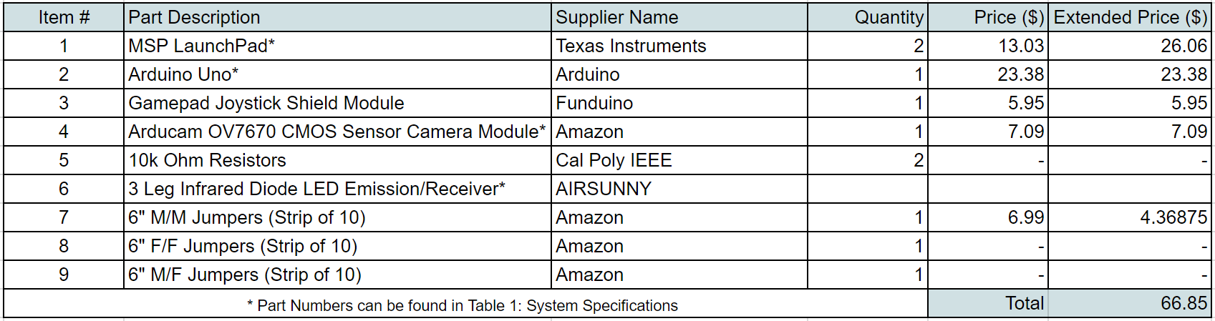

**Table 2: Bill of Materials**

Discussion, Conclusions, and Recommendations

Overall, this system was fairly straightforward to construct in software. Some small complexity came from joystick integration, but TI provides an example for joystick processing. Using the example as a base point, the remote system was built quickly in software, and no major hurdles restricted gamepad integration.

The first major setback came with IR integration. Initial testing when running the IR emitter off the MSP432’s 3V rail failed to trigger the IR receiver. Troubleshooting this problem was difficult, as the initial assumption was that the IR receiver was faulty. A 1.2V drop was measured across the IR emitter, so it was clear that the emitter was functioning, but the receiver failed to pick up any signal. Many different receivers were tested, and each failed to pick up an infrared signal.

With numerous receivers failing to sense a signal, the emitter was examined more closely. Higher voltage values and lower current limiting resistors were used to boost power to the emitter, but nothing worked. Visual examination was then performed using a low quality camera to view infrared light from both the emitter and a TV remote, and it was immediately apparent that the emitter was incredibly dim.

By lowering the current limiting resistor to 10 ohms, adding a secondary 3V source in series with the MSP432’s pin, and driving the emitter from a high drive pin on the MSP432, the brightness was boosted to a functional level.

The second setback came when integrating the camera module with the system. Initial designs had used the MSP432 to control the camera and output pictures to an attached SD card module, but this design was inefficient and required an SD card to be transferred between the system and a computer to check pictures taken. This problem was resolved when a similar project was found online utilizing an Arduino. This project used the serial port of the Arduino to transmit the picture to the PC, where a program was constantly run to receive and decode these pictures. This system was far more simple, so we integrated an Arduino into our system.

The project finally came together when enclosures were built. The first enclosure, housing the gamepad system, was designed and built from a sheet of acrylic. The top and bottom panels were cut as two separate pieces, while the sides were cut as a single piece of acrylic and bent with heat around the top and bottom panels. This resulted in rounded edges for ergonomics.

The second enclosure was built out of Lexan to simplify the construction process. Since Lexan can be bent cold into sharp bends, the second enclosure was far more angular. This was acceptable since the second enclosure housed the camera and would therefore rest on a desk while the remote would actually be handled. With both enclosures built from a clear material to display all inner hardware, the system looked very good.

Further improvements can be made with the additional inputs from the gamepad, and with a joystick there are many possibilities. One possible expansion could utilize the joystick as well as servos on the camera to allow for remote camera positioning, and additional timers implemented from the extra buttons on the gamepad to provide for delays before taking a picture. Because IR transmission is fairly common, many remote libraries exist and could be utilized to interface the camera with a TV remote as well.

Overall, this system provided a useful function, especially given the modern obsession with “selfies”. With a remote camera system, pictures can be easily taken and don’t require the camera operator to hold the camera, allowing for pictures to include the operator. With further improvements using servos, the camera could be remotely positioned, allowing for endless possibilities when taking pictures. This system can have many applications, including a computer webcam, a security camera system, or simply a self camera. With that in mind, the work put into the system and many struggles were well worth the final product.

Appendices

*Appendix A - Formatted code*

**emitterMain.c**

#include <ti/devices/msp432p4xx/inc/msp.h>

#include <ti/devices/msp432p4xx/driverlib/driverlib.h>

#include "gamepad.h"

#define SIGNALDELAY 10000

/* ADC results buffer */

int *vals;

/*

* Main function

*/

int emitterMain(void)

{

/*P2.3 output, high drive*/

P2->SEL0 &= ~BIT3;

P2->SEL1 &= ~BIT3;

P2->DS |= BIT3;

P2->DIR |= BIT3;

P2->OUT &= ~BIT3;

/*initialize gamepad */

vals = setupGamepad();

/*infinite loop*/

while(1)

{

/*get any key pressed*/

int key = getKey();

/*if A is pressed, emit a signal*/

if (key == KEY_A) {

int counter;

/*Turn on IR*/

P2->OUT |= BIT3;

/*Hold on for awhile*/

for (counter = 0; counter < SIGNALDELAY; counter++);

/*Turn off IR*/

P2->OUT &= ~BIT3;

}

}

}

/* This interrupt is fired whenever a conversion is completed and placed in

* ADC_MEM1. This signals the end of conversion and the results array is

* grabbed and placed in resultsBuffer */

void ADC14_IRQHandler(void)

{

uint64_t status;

/*check status*/

status = MAP_ADC14_getEnabledInterruptStatus();

MAP_ADC14_clearInterruptFlag(status);

/* ADC_MEM1 conversion completed */

if(status & ADC_INT1)

{

/* Store ADC14 conversion results */

vals[0] = ADC14_getResult(ADC_MEM1);

vals[1] = ADC14_getResult(ADC_MEM0);

}

}

**receiverMain.c**

#include <ti/devices/msp432p4xx/inc/msp.h>

#include <ti/devices/msp432p4xx/driverlib/driverlib.h>

#define SIGNALDELAY 100

#define WAITDELAY 10000

void receiverMain(void) {

/*P5.5 input*/

P5->SEL0 &= ~BIT5;

P5->SEL1 &= ~BIT5;

P5->DIR &= ~BIT5;

/*P6.0 output*/

P6->SEL0 &= ~BIT0;

P6->SEL1 &= ~BIT0;

P6->DIR |= BIT0;

P6->OUT &= ~BIT0;

int counter;

while (1) {

/*wait until input signal goes low*/

while (P5->IN & BIT5);

/*bring P6.0 high for a bit*/

P6->OUT |= BIT0;

for (counter = 0; counter < SIGNALDELAY; counter++);

P6->OUT &= ~BIT0;

/*wait awhile to avoid sending multiple signals*/

for (counter = 0; counter < WAITDELAY; counter++);

}

}

**gamepad.h**

#ifndef GAMEPAD_H_

#define GAMEPAD_H_

#define NO_KEY 0

#define KEY_A 1

#define KEY_B 2

#define KEY_C 3

#define KEY_D 4

#define LEFT_X 5

#define RIGHT_X 6

#define UP_Y 7

#define DOWN_Y 8

/*

* Sets up gamepad system for remote input

* Uses P4.1-P4.6

* P4.1 - A

* P4.2 - B

* P4.3 - C

* P4.4 - D

*

* returns a pointer to an X-Y value array

* 2 integer array, X in 0, Y in 1

* main is tasked with using ADC interrupts

* to populate array

*/

int* setupGamepad();

/*

* Polls for a key from gamepad

* Returns a value defined at the top of this file

*/

int getKey();

#endif /* GAMEPAD_H_ */

*Appendix B - any other supplemental material deemed necessary*

MSP432 Datasheet: *MSP432P401R, MSP432P401M SimpleLink™ Mixed-Signal Microcontrollers*; T.I.; March 2017.

AA Datasheet: *MN1500;* Duracell; June 2008.

Arducam Datasheet: *CMOS OV7670 Camera Module 1/6-Inch 0.3-Megapixel Module Rev 3.0*; OmniVision; May 2015.

Arduino Uno Datasheet: *ATmega328*; Arduino.

*Included in the PolyLearn submission is the OV7670 Camera Module source code.*